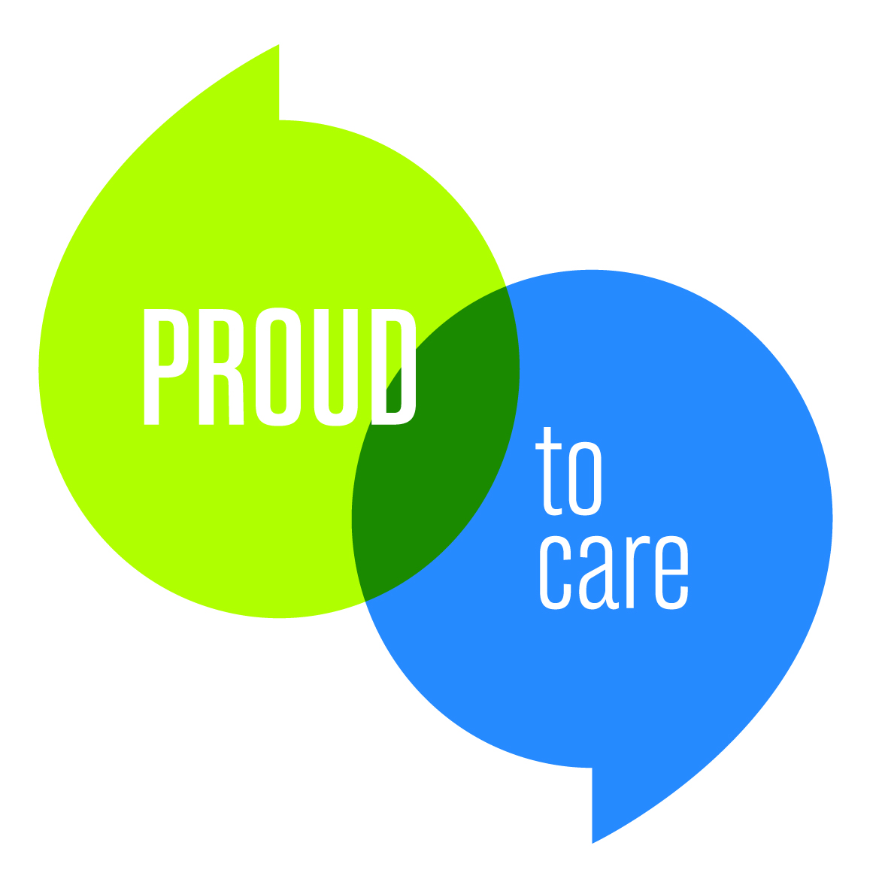 | 
REPORT TO THE PATIENT EXPERIENCE ENGAGEMENT & INSIGHT GROUP | REF: | PEEIG 21///

SUBJECT: | YOU SAID, WE DID
DATE: | April 2023 |  | PRIVATE & CONFIDENTIAL
PURPOSE: |  | Tick as applicable |  |  | Tick as applicable
PURPOSE: | For decision/approval | ✓ |  | Assurance | ✓
PURPOSE: | For review | ✓ |  | Governance | ✓
PURPOSE: | For information |  |  | Strategy
PREPARED BY: | Nicola Dent, Patient Advice and Complaints Manager
SPONSORED BY: | Gill Feerick, Head of Quality and Clinical Governance
PRESENTED BY: | James Bedford, Complaints Investigator
STRATEGIC CONTEXT
NHS Complaints good practice guidance recommends that Trusts publish information about learning and actions taken from patient feedback to reassure the public that feedback is actioned.
EXECUTIVE SUMMARY
In line with good practice guidance, the Trust publishing a few examples of learning from feedback on the public website, to be updated on a quarterly basis. This paper is a proposed draft of the quarterly update, which will include details of 3 – 4 actions/learning points from feedback and encourage service users to contact the Patient Advice and Complaints Service with their own feedback.
RECOMMENDATIONS
For discussion and approval by PEEIG members

You Said, We Did…

Feedback from patients and their families is important to us as it gives us an opportunity to identify areas for improvement. When you contact the Trust to give feedback or make a complaint we will listen to your experience and will look for learning and action that we can take to improve things for the future.

This page will be updated on a quarterly basis with a few examples of learning that has been taken from recent complaints or feedback from patients and their families.

Quarter 4 (January 2023 – March 2023)

You said: Communication with patients under the Gynaecology service could be improved, particularly when awaiting results
We did: A team process mapping session to follow a patient’s journey and identify where communication could be improved/expedited

You said: Some staff were not always demonstrating our Trust Values and Behaviours
We did: Specific values-based training with ward staff

You said: Sometimes relevant information was not being handed over between different staff members/areas caring for patients
We did: A series of reminders for staff regarding good practice in handover, using real patient/family feedback to demonstrate the impact of not giving a clear and thorough handover

If you would like to give feedback or raise a concern, please contact our Patient Advice on Complaints team at barnsleyPALS@nhs.net, by leaving a message at 01226 432330, or using the contact form from the website

