Barnsley Funeral Directors 2018 Report
Pathology would like to express their thanks to all those who were able to complete this year’s survey.
Introduction
ISO Standards subclause 4.14.3 set requirements that the laboratory management shall seek information relating to user perception as to whether the service has met the needs and requirements of its users. This survey has been performed to comply with these standards, and in doing so, will bring to the attention of the laboratory management any areas of services provided by the laboratory that require improvement.
The user satisfaction survey ran between 23rd March to 20th April 2018 and its purpose is to obtain feedback from our users on the quality of the services provided by the laboratory.
The information gained from this survey will enable laboratory management to look at the service we provide and decide how to improve it to meet the needs and requirements of our users, as part of our commitment to continually improve quality.
Method
The satisfaction survey was carried out using a questionnaire which was developed in consultation with BRILS Management Team, Clinical Heads of Department and the Laboratory Director, and comprised of 18 questions designed to elicit users’ general views on the quality of the services provided by Pathology.

The respondents were asked to rate their satisfaction using the following response options: Yes or No, except in the case of questions relating to the overall experience of collection of deceased patients, where the response options were: Does not meet my needs, acceptable and excellent. Dissatisfaction was derived from the option ‘Does not meet my needs’ whilst satisfaction was derived from the levels ‘acceptable’, and ‘excellent’. A percentage distribution of responses was used to present the data and cumulative percentage dissatisfaction compared to cumulative percentage satisfaction.

. The final question asks users to provide any comments to improve the service. These have been collated and have been discussed at a feedback session to the BRILS Management Team and actions identified where appropriate. Responses are detailed at the end of the report.

Separate user surveys have been completed for Phlebotomy (QU-AUD-SYS-GP-D-43), Hospital Users (DOC 135) and Community users (DOC329).

Hardcopy questionnaires were sent out via the mortuary.

RESULTS OF SURVEY

Responses were received from 8 Funeral Directors
Question 1: Name or Title of Person Completing Questionnaire (Optional)
This question was included so that a direct response could be given to the participant if necessary.

Question 2: Funeral Director Address
This question was included so that a direct response could be given to the participant if necessary.

Question 3: Contact Telephone Number
This question was included so that a direct response could be given to the participant if necessary.

Question 4: Are the opening times of the Mortuary suitable for collection of deceased patients?

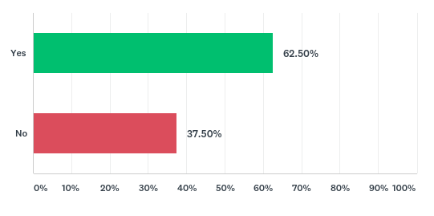
37.50% of funeral directors were not satisfied with the opening times of the Mortuary. This is an increase in dissatisfaction compared to the 2017 user survey, where all users feld that the opening times of the mortuary were acceptable, good or excellent.

Question 5: Is documentation required i.e. cremation forms, death certificates etc. completed in a timely manner?

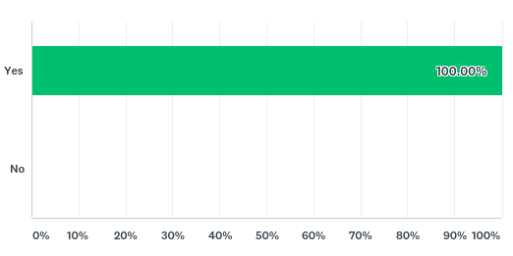

All funeral directors were satisfied with the timeliness of completion of documentation. This mirrors the results of the 2017 user survey.

Question 6: Are you satisfied with the condition and appearance of deceased patients that leave the Mortuary?

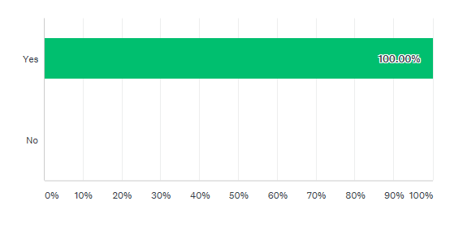
All funeral directors were satisfied with condition and appearance of the deceased. This mirrors the results of the 2017 user survey.

Question 7: Are deceased patients treated in our Mortuary with dignity and respect?

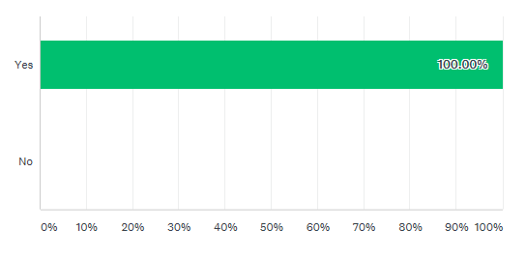
All funeral directors felt that deceased patients were treated with dignity and respect in our Mortuary. This question was not asked in 2017 therefore, we are unable to compare the response.

Question 8: Do Mortuary staff have a professional and courteous manner (both telephone and face-to-face)?

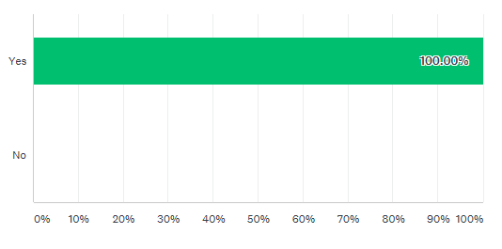
All funeral directors were satisfied with the manner of Mortuary staff. This mirrors the results of the 2017 user survey.

Question 9: Please rate your overall experience of collection of deceased patients from the Mortuary.

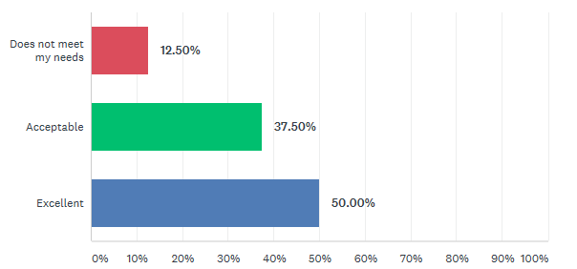

87.5% of funeral directors felt that their experience of collection of deceased patients from the Mortuary was acceptable or excellent. 12.5% (one participant) felt that their overall experience did not meet their needs. This is a decreased in satisfaction compared to 2017 whereby all funeral directors rated their overall experience as acceptable, good or excellent.

USER FEEDBACK AND SUGGESTIONS
Users were asked to provide feedback or suggestions to improve the service. Each of the comments have been split into categories in the below table to allow appropriate action to be taken.
Comment Number | Comment | Response
Compliment
1 | No. Everything is satisfactory. | Thank you. The positive results have been fed back to the Mortuary Manager to feed back to staff as part of staff meetings. The results have also been passed onto the Pathology Business and Service manager for inclusion in Staff Briefings.
2 | No quite happy or high.
3 | We often come early. Staff are happy to open up. We are happy and grateful for all the staff do for us.
4 | When we need to come early the staff always try to accommodate. Always helpful. We often bring deceased's into our care earlier than the opening mortuary time. The staff are very helpful letting us come early.
Opening Times
5 | Would be beneficial if the mortuary was open longer. | The Mortuary is routinely open for collection of the deceased between 10:30am – 12 and 1pm – 3:30pm. Outside of these times we would ask you to contact the Mortuary on 01226 432335 to arrange a time, to ensure that staff are available to assist. Please do not feel that this is an imposition, we are happy to accommodate collections outside of these times if at all possible, but do require a telephone call prior to arrival.

