Rotherham Barnsley Funeral Directors 2018 Report
Pathology would like to express their thanks to all those who were able to complete this year’s survey.
Introduction
ISO Standards subclause 4.14.3 set requirements that the laboratory management shall seek information relating to user perception as to whether the service has met the needs and requirements of its users. This survey has been performed to comply with these standards, and in doing so, will bring to the attention of the laboratory management any areas of services provided by the laboratory that require improvement.
The user satisfaction survey ran between 23rd March to 20th April 2018 and its purpose is to obtain feedback from our users on the quality of the services provided by the laboratory.
The information gained from this survey will enable laboratory management to look at the service we provide and decide how to improve it to meet the needs and requirements of our users, as part of our commitment to continually improve quality.
Method
The satisfaction survey was carried out using a questionnaire which was developed in consultation with BRILS Management Team, Clinical Heads of Department and the Laboratory Director, and comprised of 18 questions designed to elicit users’ general views on the quality of the services provided by Pathology.

The respondents were asked to rate their satisfaction using the following response options: Yes or No, except in the case of questions relating to the overall experience of collection of deceased patients, where the response options were: Does not meet my needs, acceptable and excellent. Dissatisfaction was derived from the option ‘Does not meet my needs’ whilst satisfaction was derived from the levels ‘acceptable’, and ‘excellent’. A percentage distribution of responses was used to present the data and cumulative percentage dissatisfaction compared to cumulative percentage satisfaction.

. The final question asks users to provide any comments to improve the service. These have been collated and have been discussed at a feedback session to the BRILS Management Team and actions identified where appropriate. Responses are detailed at the end of the report.

Separate user surveys have been completed for Hospital Users (DOC ???) and Community users (DOC ???).

Hardcopy questionnaires were sent out via the mortuary.

RESULTS OF SURVEY

Responses were received from 7 Funeral Directors.
Question 1: Name or Title of Person Completing Questionnaire (Optional)
This question was included so that a direct response could be given to the participant if necessary.

Question 2: Funeral Director Address
This question was included so that a direct response could be given to the participant if necessary.

Question 3: Contact Telephone Number
This question was included so that a direct response could be given to the participant if necessary.

Question 4: Are the opening times of the Mortuary suitable for collection of deceased patients?

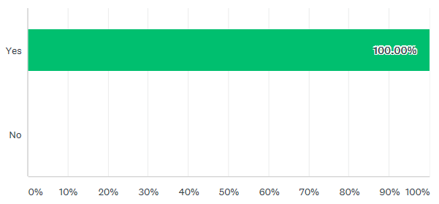
100% funeral directors were not satisfied with the opening times of the Mortuary.

Question 5: Is documentation required i.e. cremation forms, death certificates etc. completed in a timely manner?

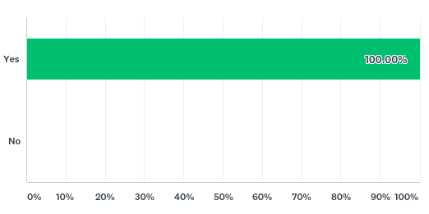

All funeral directors were satisfied with the timeliness of completion of documentation. This mirrors the results of the 2017 user survey.

Question 6: Are you satisfied with the condition and appearance of deceased patients that leave the Mortuary?

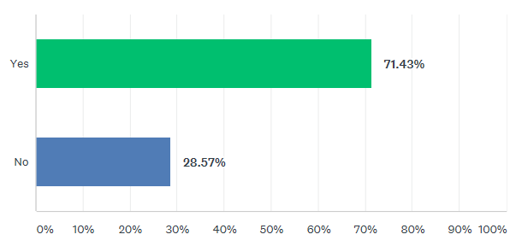
28.57% of funeral directors were not satisfied with condition and appearance of the deceased. This in an increased in dissatisfaction from the 2017 survey, where 12.50% of users felt that the condition of the deceased was poor..

Question 7: Are deceased patients treated in our Mortuary with dignity and respect?

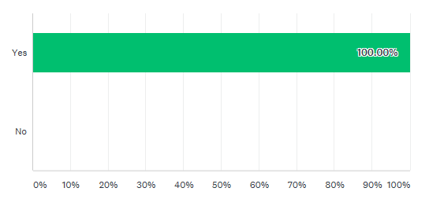
All funeral directors felt that deceased patients were treated with dignity and respect in our Mortuary. This question was not asked in 2017 therefore, we are unable to compare the response.

Question 8: Do Mortuary staff have a professional and courteous manner (both telephone and face-to-face)?

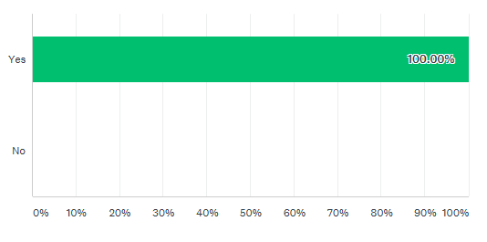
All funeral directors were satisfied with the manner of Mortuary staff. Is an increase from 2017 where 12.50% of users felt that Mortuary staff had a poor professional and courteous manner.

Question 9: Please rate your overall experience of collection of deceased patients from the Mortuary.

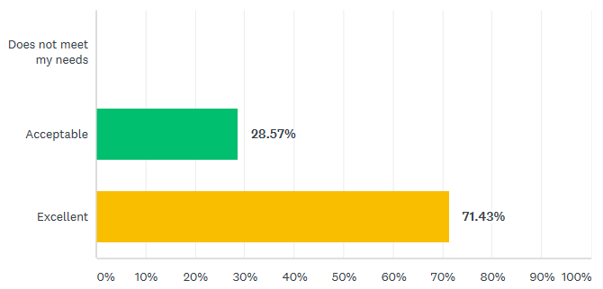

100% of funeral directors felt that their experience of collection of deceased patients from the Mortuary was acceptable or excellent. This is mirrors the 2017 user survey.

USER FEEDBACK AND SUGGESTIONS
Users were asked to provide feedback or suggestions to improve the service. Each of the comments have been split into categories in the below table to allow appropriate action to be taken.
Comment Number | Comment | Response
Compliment
1 | All staff amazing :-) | Thank you. The positive results have been fed back to the Mortuary Manager to feed back to staff as part of staff meetings. The results have also been passed onto the Pathology Business and Service manager for inclusion in Staff Briefings.
Condition of the deceased.
2 | Just of lately a few deceased have had leakage. I think the mortuary is well equipped. | It would be useful to have examples to be able to comment fully. Is this leakage following post-mortem? There are some patients where leakage is difficult to control depending on skin texture – if skin very frail and patient oedematous. Please contact us to discuss if you find that you are not satisfied with the condition of the deceased.
3 | Condition of deceased - Not always satisfied with the condition and appearance - Due to plastic bags being used for the deceased, this causes sweating and deterioration. Mortuary opening hours are acceptable aside from when post-mortems are carried out and a member of staff is on annual leave or absent through sickness. | Bags are used to aid in health and safety. The use of bags was instigated many years ago with discussions with infection control. It allows porters to move deceased without any issue with leakage. We are aware that condensation may occur when putting deceased into fridges but the bags are left slightly undone to allow air to move.  Mortuary opening hours: as PMs are undertaken twice per week, on the days of PMs all staff may be in the PM room up to 9am (due to volume of work). However, they do leave a note with the phone number and have a phone available in the PM room. At 9am one of the staff leaves the PM room to assist the funeral directors. If there is sickness or annual leave, there may only be 1 member of staff available but FDs will still be able to access the mortuary and if necessary a MLA from the lab will cover.

